TESTING

Equivalence Partitioning 1:
I have used equivalence partitioning method with respect to type of input commands and have divided the entire set of unix commands into these categories: commands that work on the files (touch,cat,chmod etc.,), process control commands (ps,clear etc.,), utilities(ls,find,grep etc.,), miscellaneous commands(date,whoami). I have tested the code against these cases, using a mix of them in the command strings.

Test Command strings and Outputs for Equivalence Partitioning 1:

Command String 1: ps;ls;date;cat testhelper.txt

This command covers the sequential operation of the commands (one from each partition).

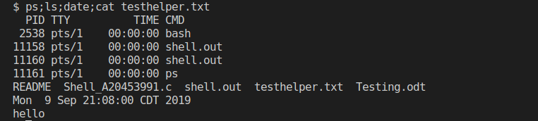

Command String 2: ps;ls;date&cat testhelper.txt

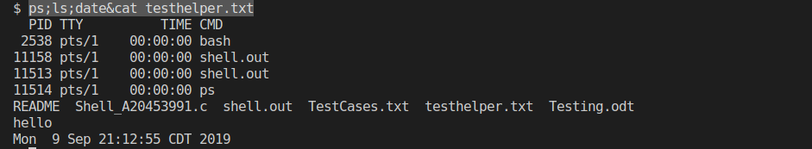

As can be seen from the output, date and cat commands are running in parallel and the output of cat is seen before the output of date command

Command String 3: ps;ls&date&cat testhelper.txt

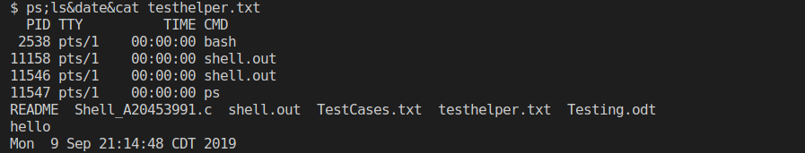

Command String 4: ps&ls&date&cat testhelper.txt

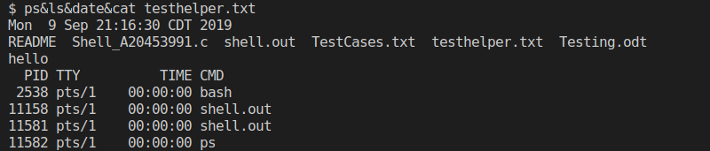
Command String 5: ps&ls;date;cat testhelper.txt
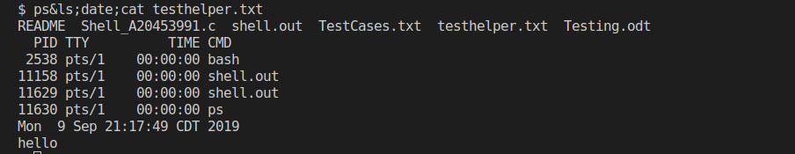
Command String 6: ps&ls;date&cat testhelper.txt

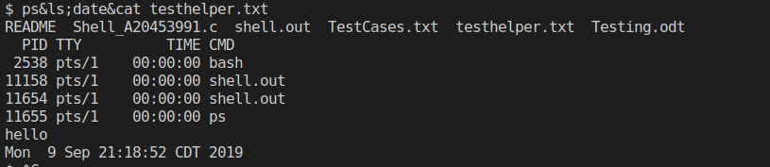

Command string 7: ps&ls&date;cat testhelper.txt

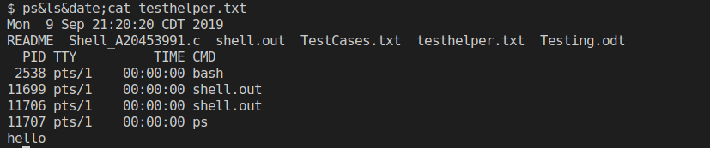
Command 8: ps;ls&date;cat testhelper.txt

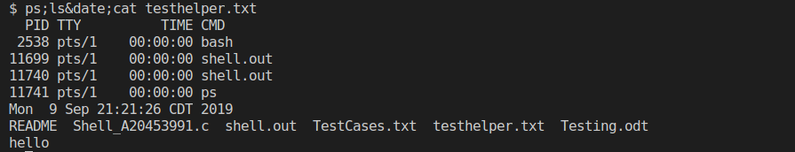

From the above cases, it can be seen from the output that the commands that have to be run sequentially are running one after the other and the commands that have to be run in parallel are running in parallel.

Equivalence Partitioning 2:
I have done one more partitioning with respect to mix of number of sequence and parallel operators in a given command string. These partitions are: 1 sequence or parallel operator in the command string, 2 sequence or parallel operators in the command string, 3 or more sequence or parallel operators in the command string and so on.

Test Command strings and Outputs for Equivalence Partitioning 2:
Command string 1: ls;echo "hello"

Command string 2: ls&echo “hello”

Command string 3: ls&echo "hello"&date
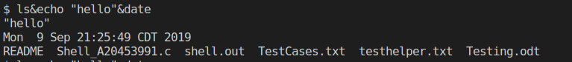

Command string 4: ls;echo "hello";date

Command string 5: ls;echo "hello"&date
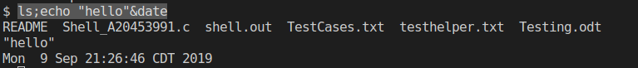

Corner cases:
Also, I have tested the code against the following corner cases:
1. No commands between ; and & operators
2. Command terminates with a & (To satisfy the Requirement #6)
3. There is no unix command that matches the entered string
4. Repetitive commands in the command string
5. Only one command in the command string

Test cases for covering corner cases:
Command 1: ls&;
No command between & and ;

Command 2: ls&

Command 3: asdf

When no such command exists, an custom error message is thrown to the user.

Command 4: ls;ls;

Repetitive commands in the string. Also covers the case where a command can be terminated by ;

Command 5: ls

Only one command given

The above cases cover almost all the scenarios that a user in the industry can face. Considering all these cases, I have did an exhaustive set of testing and faced no errors.

